CO 2 - ASSESSMENT TOOL -1

Name : Lanka Kavya Subject Code : CSA1003
Registration Number : 192472298 Subject Name : Software Engineering
Hotel Reservation and Room Management Platform with Dynamic Pricing

Software Requirement Specification (SRS)

1. Study and Analyze the Scenario

Business Domain
Hospitality and Hotel Management.

Problem Description
Many hotels still rely on manual booking systems or outdated software, leading to booking conflicts, inefficient room management, pricing inconsistencies, and poor customer experience. The proposed system is a Hotel Reservation and Room Management Platform with Dynamic Pricing that automates hotel operations, provides real-time room availability, supports online booking and payments, and dynamically adjusts room prices to maximize occupancy and revenue.

Objectives
- Automate hotel reservations.
- Manage room availability in real time.
- Introduce dynamic pricing.
- Reduce manual errors and double bookings.
- Increase customer satisfaction.
- Improve hotel revenue and operational efficiency.

2. Functional and Non-Functional Requirements

Functional Requirements
- User Registration and Login
- User Authentication
- Search Available Rooms
- View Room Details
- Dynamic Room Pricing
- Room Reservation
- Booking Confirmation
- Booking Cancellation
- Online Payment Processing
- Payment History
- Room Management (Add, Edit, Delete Rooms)
- Customer Profile Management
- Booking Management
- Occupancy Tracking
- Generate Booking Reports
- Revenue Reports
- Email/SMS Notifications
- Review and Rating System
- Admin Dashboard
- User Logout

Non-Functional Requirements
- Performance

Security

Reliability

Usability

Scalability

Maintainability

Availability

3. Actors and Use Cases

Primary Actors
- Customer
- Hotel Administrator

Secondary Actors
- Hotel Staff
- Payment Gateway
- Email/SMS Notification Service
- System Administrator

Major Use Cases

Customer

Hotel Administrator

Hotel Staff

Payment Gateway

Use Case Diagram (Text Representation)
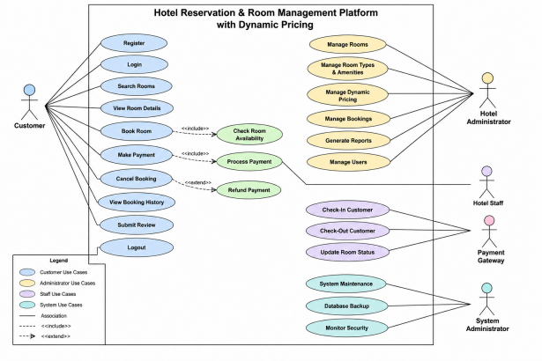

4. Software Requirement Specification (SRS)

Introduction
The Hotel Reservation and Room Management Platform with Dynamic Pricing is designed to automate hotel operations by providing online booking services, real-time room management, secure payment processing, and intelligent pricing based on demand.

Functional Requirements
- User Registration
- Login Authentication
- Room Search
- Reservation
- Dynamic Pricing

Non-Functional Requirements
- Security
- Reliability
- Performance
- Scalability

Use Case Descriptions

Use Case: Book Room
Actor: Customer
Precondition: Customer is logged in.
Main Flow:
- Search available rooms.
- Select room.
- Enter booking details.
- View dynamic price.
- Make payment.
- Booking confirmed.

Data Requirements

Customer Data
- Customer ID
- Name
- Email
- Phone Number
- Address

Room Data
- Room ID
- Room Type
- Price
- Availability
- Capacity

Booking Data
- Booking ID
- Check-In Date
- Check-Out Date

Payment Data
- Payment ID
- Transaction ID
- Payment Status

External Interface Requirements

User Interface
- Responsive web interface
- Mobile-friendly layout

Hardware Interface
- Server
- Client Computer
- Smartphone

Software Interface
- Payment Gateway API
- Email/SMS API
- Database Server

Communication Interface
- Internet
- HTTPS Protocol

5. Assumptions and Constraints

Assumptions
- Users have internet access.
- Online payment services are available.
- Hotel staff are trained to use the system.
- Dynamic pricing rules are predefined by administrators.

Constraints

Operational , Economic, Legal etc…,

6. Requirement Validation

Completeness
All stakeholder requirements including booking, pricing, payment, room management, and reporting are covered.

Consistency
The functional and non-functional requirements do not conflict and support the project objectives.

Missing Requirements
Future versions may include:
- AI-based demand prediction
- Loyalty rewards program
- Multi-language support
- Mobile application
- Chatbot-based customer assistance

